How to Apply
To register for this event, please use the template below to apply, and fill in all the required fields before sending mail to : ipteca@t.gifu-u.ac.jp
＝＝＝＝＝＝＝＝＝＝＝＝＝＝＝＝＝＝＝＝＝＝＝＝＝＝＝＝＝＝＝＝＝＝＝＝
Template
【件名(Title)：「2026年度 第1回航空宇宙人材育成講演会申込」】
【 お名前(Name） 】
【 所属・役職(Affiliation / Job Title) 】
【 Email(Email Address) 】
【 参加方法(Participation Method) 】
【 今後のイベント案内(Future Event Notifications) 】
【 お問い合わせ内容(Questions / Comments) 】
【 個人情報保護方針(Agreement with Privacy Policy) 】
＝＝＝＝＝＝＝＝＝＝＝＝＝＝＝＝＝＝＝＝＝＝＝＝＝＝＝＝＝＝＝＝＝＝＝＝
The explanations for each item in the template are provided below.
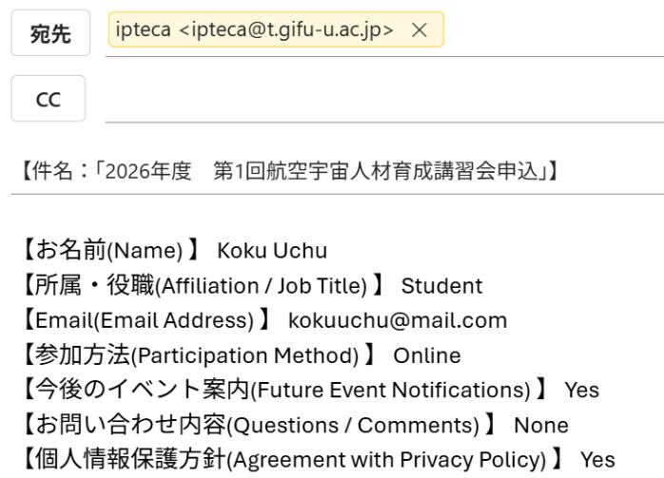
【 お名前(Name） 】 Please enter your name.
【 所属・役職(Affiliation / Job Title) 】 Please enter your affiliation and job title.
【 Email(Email Address) 】 Please enter your email address.
【 参加方法(Participation Method) 】 Please indicate your preferred method of participation.( Please write either In-person or Online.)
【 今後のイベント案内(Future Event Notifications) 】 Would you like to receive information about future events organized by the IPTECA Center? Please answer Yes or No.
【 お問い合わせ内容(Questions / Comments) 】If you have any questions or comments, please write them here.
【 個人情報保護方針(Agreement with Privacy Policy) 】 Do you agree with the Gifu University Privacy Policy? Please answer Yes or No.

for example:

